# **CS 558**

# **Introduction to Information Visualization**

# **Project 1**

# **Submitted By:**

# **Aman Pandita**

# **Manpreet Kaur**

# **Electrifying the Road: Tesla's Meteoric Rise and the Great EV Race in the Automotive World**

The market for electric vehicles (EVs) has grown rapidly in recent years as a result of technology developments and rising environmental awareness. Our study compares the performance of 149 other manufacturers with Tesla, Ford, Nissan, Chevrolet, and Oregon's new electric vehicle registrations since 1980. I monitored the number of new registrations over time using a series of line graphs and scatterplots, which showed a definite rising trend in EV adoption. This pattern highlights how popular electric vehicles are becoming as buyers become more aware of their favorable economic and environmental effects.

The dataset selected for analysis consists of car registration data spanning over four decades, from 1980 to 2022. It contains information on various car brands, including Tesla, Chevrolet, Nissan, Toyota, Ford, and many others. The primary goal of this analysis is to uncover meaningful insights and trends in the automotive industry, with a particular focus on the impact of electric vehicles, as spearheaded by Tesla.

Once we analyze the data in figure 1, I observed a exponentiol increase in the new EV registrations over time from starting from 1980 to 2022, reflecting the overall growth of the Oregon’s EV Market. However, due to increased rivalry amongst large companies, not all brands have had the same growth; some have outperformed others.

Upon Visualizing the data, it was evident that the other car brands also had a significant incrase in the EV sales as we can see in the figure 2. This suggests that the increase in the intent of the population towards EVs when other brands offered it at a comparatively lower price point.

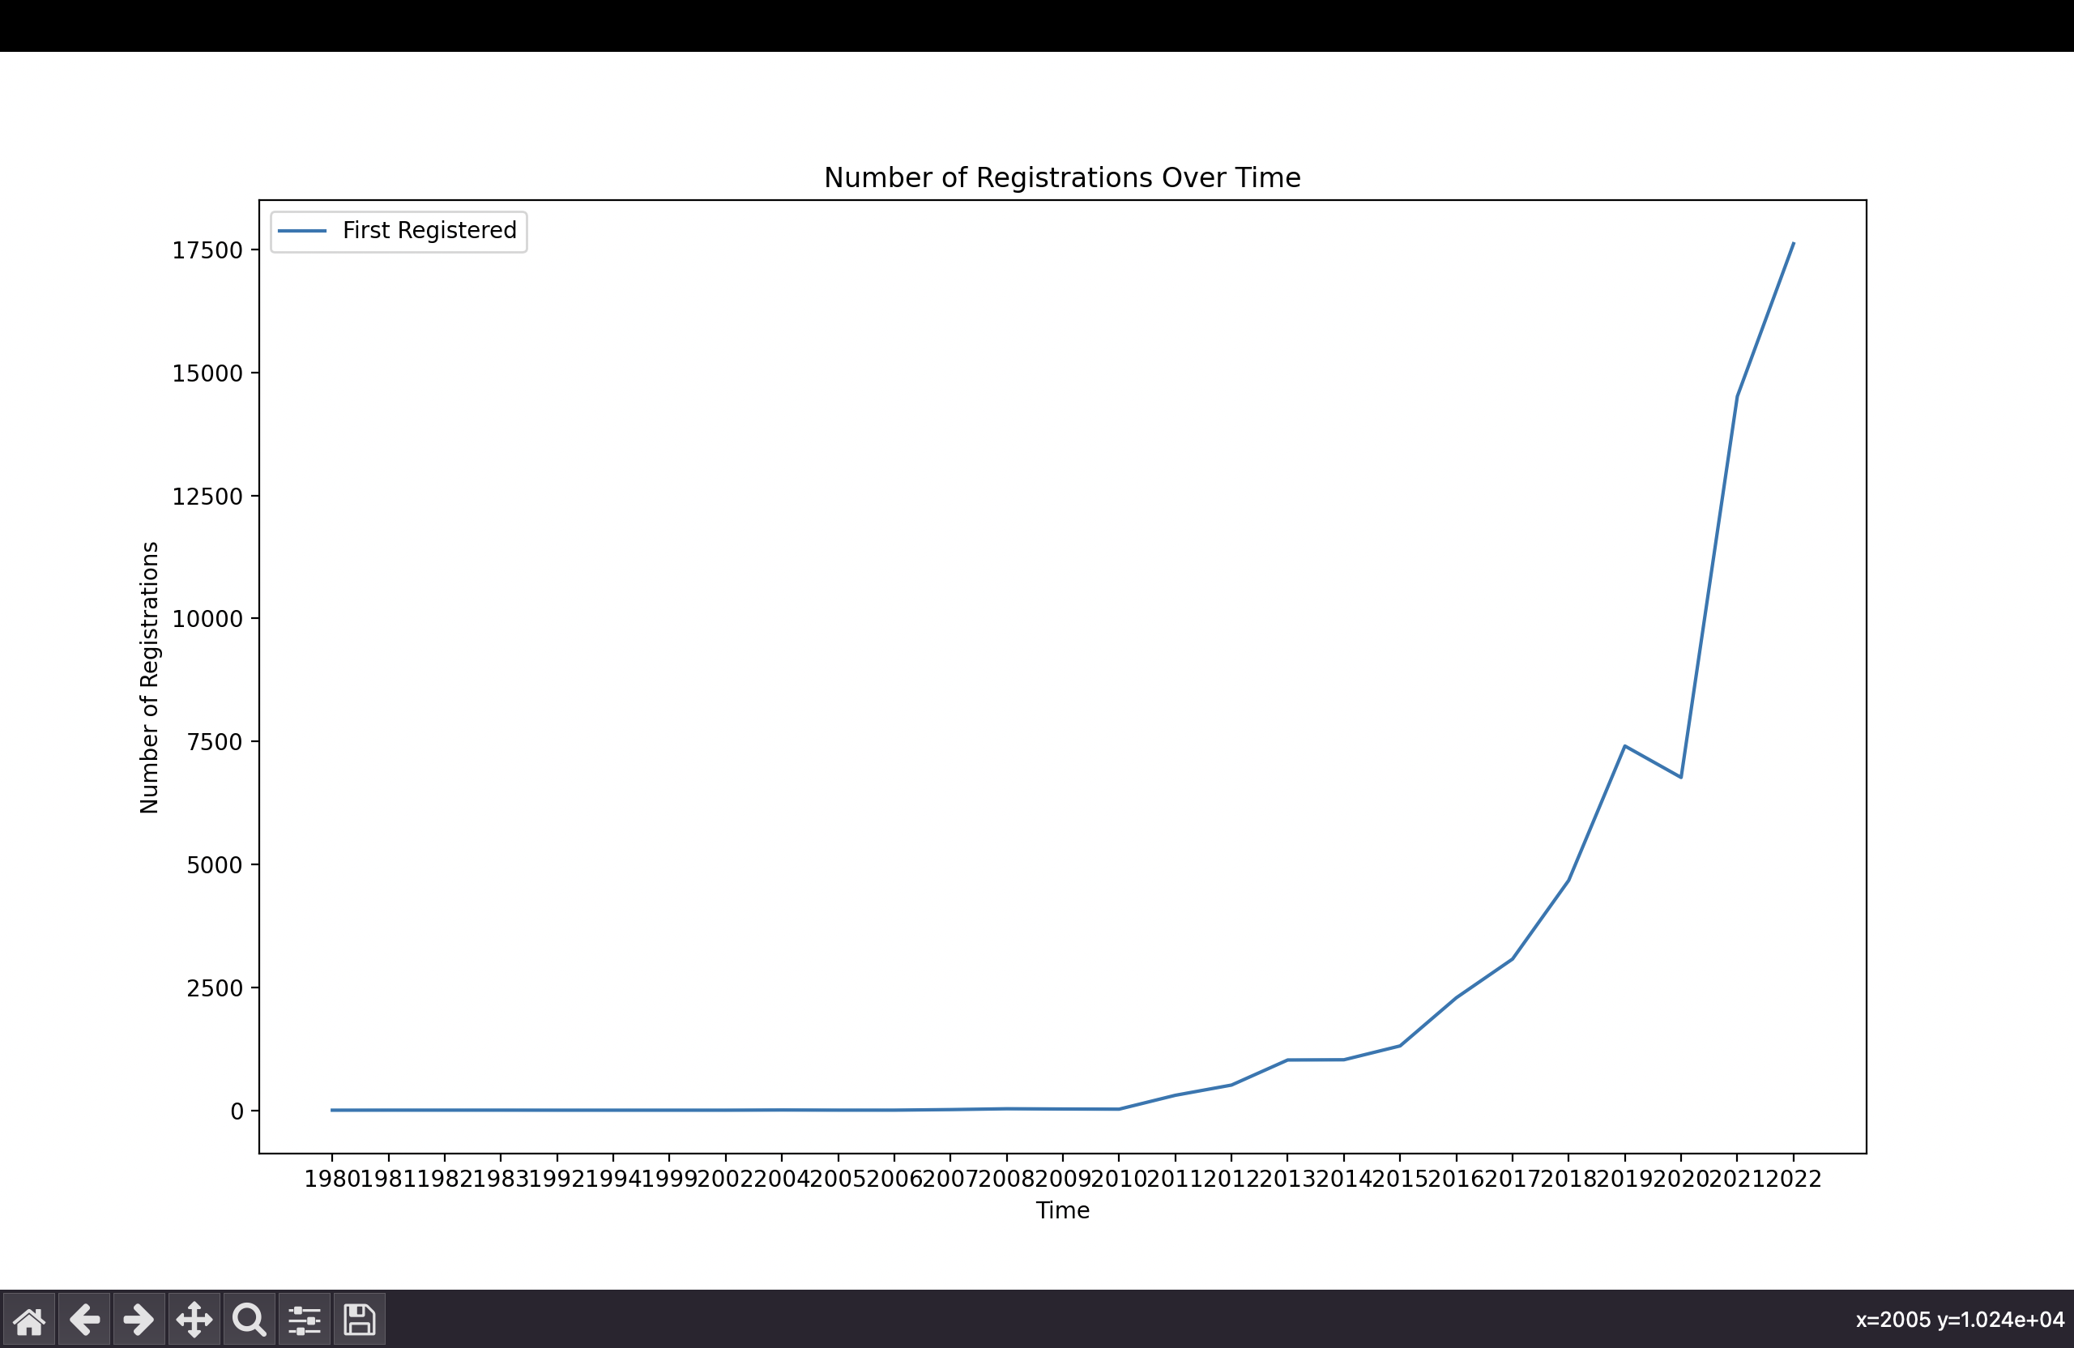

*Figure 1*

* **Figure 1 (Number of new registrations over time vs. time from 1980-2022):**

This compelling visualization highlights the dramatic growth of the EV automobile market from 1980 to 2022, capturing the evolving landscape of car registrations across major brands, including Tesla, Chevrolet, Nissan, Toyota, Ford, and others. The chart illustrates the competition between these brands as they vie for dominance in the industry.

*Figure 2*

* **Figure 2 (Number of new Tesla registrations over time vs. others over time):**

This striking plot showcases the meteoric rise of Tesla as it disrupts the traditional automotive industry. The visualization contrasts Tesla's growth with that of other major car brands, revealing the company's unique trajectory and the increasing popularity of electric vehicles in the market.

The explosive growth of Tesla, a leader in electric car technology, is a significant trend that sticks out. The data demonstrates that Tesla has grown exceptionally recently, beating several of its well-known rivals. This demonstrates the growing acceptance and popularity of electric cars on the market, which has enormous implications for both the environment and the future of transportation.

*Figure 3*

* **Figure 3 (A Battle of Brands: Comparing the Influence and Reach of Top Car Manufacturers in the Automotive Market)**

*Figure 4*

* **Figure 4 (A Comprehensive Snapshot: Visualizing Market Share Distribution Among Top Car Brands and the Competitive Landscape)**

The distribution of market share among the leading auto brands and their relative positions in the market are also clearly shown by the tree map and radar map visualizations. We can recognize market leaders, trailblazers, and up-and-coming competitors in the automobile sector thanks to these visualizations.

In conclusion, this research highlights the significance of comprehending major trends and the effects of electric vehicles while shedding light on the dynamic character of the automotive sector. These insights will be essential in forming industry strategies and assisting decision-making for both incumbent businesses and new entrants as we progress towards a more sustainable future.